

**Data Technician**

|  |
| --- |
|  |

|  |
| --- |
| Name: Alaa Mostafa |
| Course Date: 16/12/24 |
|  |

**Table of contents**

Day 1: Task 1 2

Day 2: Task 1 2

Day 2: Task 2 3

Day 2: Task 3 4

Day 3: Task 1 4

Day 3: Task 2 5

Dataset: 5

Step 1: Create a Pivot Table 5

Step 2: Use the SWITCH Function 5

Submission: 6

Day 3: Task 3 6

Day 4: Task 1 7

Course Notes 9

Additional Information 10

# Day 1: Task 1

Please complete the below boxes on commons laws and regulations that must be followed when working with customers data, use the below bulleted list to support your answers.

* What is it
* Why is it important
* Provide a real-world example of how you can follow it
* How does it impact working with data
* What could happen if you breached it

|  |  |
| --- | --- |
| Data Protection Act | The **Data Protection Act (DPA)** is a law designed to protect people’s personal data and govern how organizations, businesses, and governments collect, store, use, and share it.  It is important because it Protects People’s Privacy, builds trust,Prevents Misuse of Data, Improves Security.  A real-world example:  Example **:** InaSchool   * Situation: I am a teacher handling student records. * HowtofollowtheDPA:   + Store grades and reports securely (password-protected files or locked cabinet).   + Share a student’s information only with relevant staff (not with other students or parents without permission).   + Shred old records when no longer needed.   Working under the Data Protection Act (DPA) has a big impact on how employees, businesses, and organizations handle data in their daily work.  If I breach, there is risk of harm, fraud, or distress. |
| GDPR | General Data Protection Regulation.  Protects people’s **personal data**  Gives individuals **more control** over how organizations collect, use, and share their data.  Applies to **any organization** that handles the data of people in the EU/UK, even if the company is based outside Europe.  Real world example:   * **Situation**: A hospital stores patient records digitally. * **GDPR compliance**:   + Only authorized doctors/nurses can access our records.   + If we move to another hospital, we can request your records be transferred (**data portability**).   + We can ask the hospital to correct any wrong information in our file.   Breaching GDPR can lead to huge fines, job loss, criminal charges, and loss of trust |
| Freedom of Information Act | The **Freedom of Information Act (FOIA)** is a law that gives the public the right to access information held by public authorities (like government departments, local councils, NHS, police, schools, etc.).  Real world example:  **Example: Schools**   * **Situation**: A parent asks a local education authority for the number of children excluded from schools in their area. * **Outcome**: The authority provides anonymized data, which helps the parent understand local education issues.   Breaching FOIA mainly affects **public authorities**. Consequences include **ICO investigations, enforcement orders, legal action, and loss of public trust**, while employees can face disciplinary action for deliberately obstructing requests. |
| Computer Misuse Act | The **Computer Misuse Act (CMA)** is a law in the UK designed to **prevent cybercrime** and protect computer systems and data from unauthorized access or misuse.  Real world example:  **Example: Social Media Account Hacking**   * **Situation**: Someone hacks into another person’s Instagram or Facebook account without permission. * **Outcome**: This is **unauthorized access under the CMA**, and the hacker could face **2–5 years in prison** depending on intent.   Breaching the CMA can lead to **prison, fines, criminal records, and reputational harm**. |

# Day 2: Task 1

Please research and complete the following tasks within the retail-sales_dataset.xlsx document, paste a print screen into the provided boxes below:

1. In the sheet ‘retail_sales_dataset’ add all available data between columns A –J into a ‘table’
2. Using the ‘sort’ function, sort ‘Age’ to ‘largest to smallest’
3. Using the ‘SUM’ function, show me the commission total in cell ‘L10’
4. Using the ‘AVERAGE’ function, show me the average commission in cell ‘L11’

|  |  |
| --- | --- |
| Print screen 1 |  |
| Print screen 2 |  |
| Print screen 3 |  |
| Print screen 4 |  |

# Day 2: Task 2

Please research and complete the following tasks within the retail-sales_dataset.xlsx document, paste print screens into the provided box below:

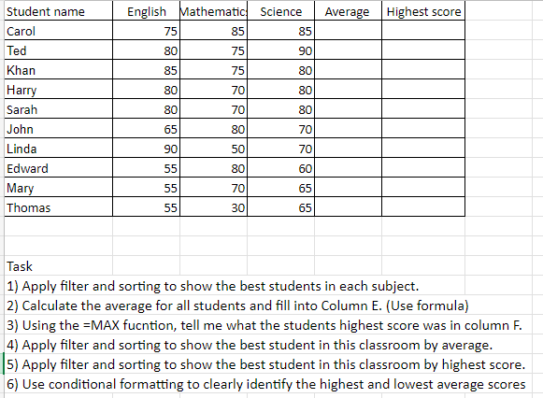

|  |  |
| --- | --- |
| Print screen 1 |  |

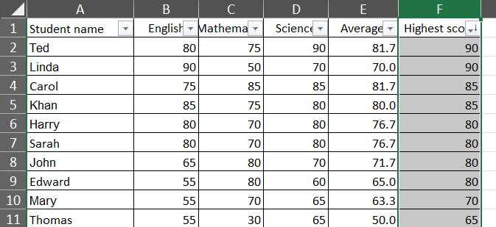

# Day 2: Task 3

Using the skills developed today, have some fun with the data set you have imported. Paste your work below and enjoy!

|  |  |
| --- | --- |
| Print screen 1 |  |
|  | Creating Table |
|  | Sorted Age from smallest to largest |
|  | Created pivot table and inserted slicer for Category column |

# Day 3: Task 1

Please download the dataset ‘Day_3_Task_1_Bike_Sales_Pivot_Lab.xlsx’ and the lab instructions.

Do not worry if you do not complete the lab, just working with data and playing with the pivot table will be good experience.

Please paste your final pivot table below and complete the reflection questions:

|  |  |
| --- | --- |
| Print screen 1 | Pivot Table |
| In which markets does Germany have customers? |  |
| What country has sales in all markets? |  |
| What are the most profitable markets by country, age group, and gender? |  |
| Any other findings? |  |

# Day 3: Task 2

The dataset below tracks the sales performance of different products in various counties in England. Please paste the dataset into a blank Excel workbook. Your task is to:

* **Create a Pivot Table** to summarise the data by county and product.
* **Use the SWITCH function** to categorise products based on their sales volume.

#### **Dataset:**

|  |  |  |
| --- | --- | --- |
| **County** | **Product** | **Sales Volume** |
| Yorkshire | Laptops | 500 |
| Yorkshire | Smartphones | 200 |
| Cornwall | Laptops | 700 |
| Cornwall | Printers | 400 |
| Lancashire | Smartphones | 150 |
| Lancashire | Laptops | 600 |
| Essex | Printers | 800 |
| Essex | Smartphones | 300 |
| Durham | Laptops | 250 |
| Durham | Printers | 300 |
| Greater Manchester | Smartphones | 600 |
| Greater Manchester | Laptops | 400 |

#### **Step 1: Create a Pivot Table**

* Select the dataset (columns A to C).
* Insert a Pivot Table to summarise the data by **County** in the rows and **Products** in the columns. Use **Sales Volume** as the value to be summarised.

#### **Step 2: Use the SWITCH Function**

In a new column next to your data, use the SWITCH function to categorise products based on **Sales Volume** as follows:

* + For sales greater than 600: **"High"**
  + For sales between 300 and 600: **"Medium"**
  + For sales less than 300: **"Low"**

**SWITCH Function Example**:

=SWITCH(TRUE, C2 > 600, "High", C2 >= 300, "Medium", "Low")

* Apply this formula to each row, and check if the products are categorised correctly.

#### **Submission:**

* A completed Pivot Table summarising sales by county and product.
* A new column in the dataset categorising products by sales volume using the SWITCH function.
  + Please paste your completed work below

|  |  |
| --- | --- |
| Print screen 1 | After categorizing products using SWITCH function |

# Day 3: Task 3

Please download the dataset ‘Day_3_Task_3_Bike_Sales_Visualisations_Lab.xlsx’ and the the lab instructions. Do not worry if you do not complete the lab, just working with data and playing with the charts will be good experience.

Please paste your results below:

|  |  |
| --- | --- |
| Print screen 1 | Line Chart for Revenue and Profit by Year worksheet    Bar Chart |
|  | Pie Chart |

# Day 4: Task 1

You have been asked to deliver your analysis findings to the board of directors, with your analysis you have identified that customers are leaving your company at the 12-month point, this is typically when they receive their renewal price.

Conduct research and complete the below questions:

|  |  |
| --- | --- |
| How would you prepare for the delivery? | * Make sure every slide, chart, and comment ties back to the message *“*Customers are leaving us at the 12-month renewal point, and renewal pricing is the main trigger.” * Using one clean graph to show the 12-month drop-off. * Showing the curve/renewal trend and relevant customer feedback. * A timeline of immediate actions and long-term strategies. * Be confident but concise * Frame the issue as solvable * Ending with a clear call to action. |
| What tools would you use for the delivery? | * Presentation Tools like PowerPoint or Google slides. * Data Visualization (Excel, Tableau, or Power BI). * Communication tools like printed handouts. |
| What is prospecting and why would you complete this before your delivery? | In business communication, prospecting means researching and understanding your audience before presenting.  The reason to complete this before:   1. **Know my Audience’s Priorities**    * Some board members may focus on **financial impact**, others on **customer experience**, or **competitive positioning**. 2. **Anticipate Questions**    * Understanding their backgrounds (finance, operations, marketing, etc.) helps to predict the kinds of questions they’ll ask. 3. **Tailor my Recommendations**    * we can frame our findings in a way that resonates with board-level strategy rather than day-to-day operations. 4. **Build Credibility**    * Showing that I have done my homework about what matters to them increases trust and buy-in. 5. **Make the Ask Clear**    * Prospecting helps me align my request (e.g., approval for a retention initiative) with their strategic goals. |
| Tell me best practices for public speaking and providing updates to senior leaders | **1. Start with the Headline**   * Don’t build suspense — **open with the key message**: *“Our analysis shows customers are leaving at the 12-month renewal point, mainly due to pricing.”*   **2. Keep it Concise & Structured**   * Limit updates to **3–5 key points** — if you can’t explain it in 5 minutes, simplify further.   **3. Be Data-Driven but Visual**   * Show trends with **simple charts or visuals**, not dense spreadsheets.   **4. Anticipate and Welcome Questions**   * Have an **appendix or backup data** ready, but don’t flood them with details upfront.   **5. Tailor to the Audience**   * Senior leaders care about **strategy, risks, and outcomes**, not operational detail.   **6. Deliver with Confidence**   * Maintain eye contact, speak clearly, and don’t rush.   **7. Focus on the Future, Not Just the Past**   * Analysis is important, but leaders want to know what’s next.   **8. Respect Their Time**   * Be punctual, stick to the slot, and leave time for discussion. * Have a **clear closing line**Top of Form   Bottom of Form |
| What will you show the board in your delivery? | **The Key Finding (The Headline)**   * A **clear statement**   **2. The Evidence (Why This Matters)**   * Simple curve or retention chart * Customer insights/feedback snippets   **3. The Root Cause Analysis**Bottom of Form |
| How will you articulate the changes that are needed? | I articulate the change by tying evidence to financial impact, showing a clear path forward, and making a specific ask. |
| Provide a list of online resources and videos that will support your preparation for public speaking | 1. Detailed course like Coursera or Harvard. 2. Videos like “Speaking to Senior Leaders” and “Public Speaking Hacks” to refine style and delivery. 3. Read articles like Harvard’s 4. Practice actively |
| Evaluate tools that provide visualisation.  Tell me what they are.  Tell me what you would choose when delivering your presentation and why | 1. Microsoft Excel   * Best For: Basic charts, tables, and quick data analysis. * **Pros**: Widely used, easy to learn, integrates well with other Microsoft Office tools. * **Cons**: Limited interactivity and advanced visualization features.   2.Tableau   * Best For: Advanced data analysis and business intelligence. * **Pros**: Highly customizable dashboards, strong visualization design control. * **Cons**: Steep learning curve, may be overwhelming for beginners.  **3.Microsoft Power BI**  * **Best For**: Business intelligence and reporting within the Microsoft ecosystem. * **Pros**: Deep integration with Microsoft stack, cost-effective for Microsoft users. * **Cons**: Interface can be complex for new users.   4.Google Looker Studio   * Best For: Creating interactive dashboards and reports. * Pros: Free, web-based, integrates with Google Analytics, Sheets, and other data sources. * Cons: May require a Google account; some advanced features have a learning curve.   Assuming I have to deliver to a mixed audience (some technical, some less so), and I want engagement + clarity + professionalism, I would pick:   |  | | --- | | Power BI-Formal presentation of findings, possibly in-person |   -   |  |  | | --- | --- | | Power BI or Tableau- Remote presentation / interactive dashboard |  | |

|  |
| --- |
| **Course Notes** |

It is recommended to take notes from the course, use the space below to do so, or use the revision guide shared with the class:

|  |
| --- |
|  |

|  |
| --- |
| **Additional Information** |

We have included a range of additional links to further resources and information that you may find useful, these can be found within your revision guide.

**END OF WORKBOOK**

**Please check through your work thoroughly before submitting and update the table of contents if required.**

**Please send your completed work booklet to your trainer.**